Winget
# Source: AI Source: Provided by: [Data Path: Persons Table -> ID Column: 1, Name_En Column: Motasem Essam] -> From: [Chatgpt (GPT‑5 Mini)] on [1/26/2026]
Winget (short for Windows Package Manager) is a command-line tool for installing and managing software on Windows, officially developed by Microsoft.

🪟 What Winget Does:
# Source: AI Source: Provided by: [Data Path: Persons Table -> ID Column: 1, Name_En Column: Motasem Essam] -> From: [Chatgpt (GPT‑5 Mini)] on [1/26/2026]
It allows you to:
- 🔍 Search for software
- 📦 Install apps and tools
- 🔁 Update installed software
- ❌ Uninstall software
- 🔄 Upgrade all apps in one command
All from the command line — no clicking through installer wizards.

✅ Why Use Winget?
# Source: AI Source: Provided by: [Data Path: Persons Table -> ID Column: 1, Name_En Column: Motasem Essam] -> From: [Chatgpt (GPT‑5 Mini)] on [1/26/2026]
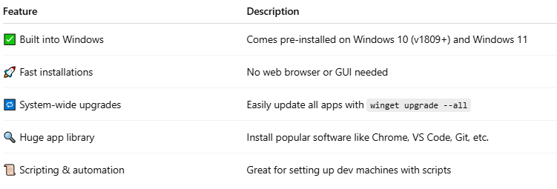

Feature | Description
✅ Built into Windows | Comes pre-installed on Windows 10 (v1809+) and Windows 11
🚀 Fast installations | No web browser or GUI needed
🔁 System-wide upgrades | Easily update all apps with winget upgrade --all
🔍 Huge app library | Install popular software like Chrome, VS Code, Git, etc.
📜 Scripting & automation | Great for setting up dev machines with scripts

📦 Example Commands
# Source: AI Source: Provided by: [Data Path: Persons Table -> ID Column: 1, Name_En Column: Motasem Essam] -> From: [Chatgpt (GPT‑5 Mini)] on [1/26/2026]
✅ Install an App:
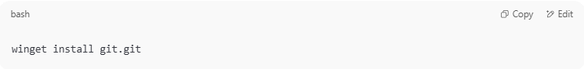
winget install git.git

🔎 Search for a Package:
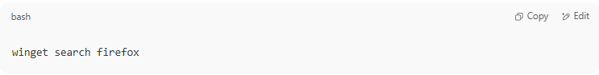
winget search firefox

🔄 Upgrade a Specific App:
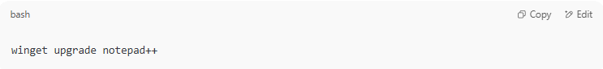
winget upgrade notepad++

🔃 Upgrade All:
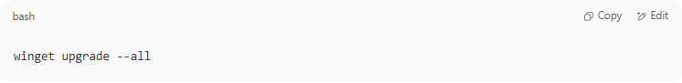
winget upgrade --all

❌ Uninstall:
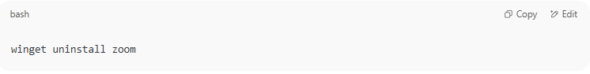
winget uninstall zoom

🔍 How to Check if You Have Winget Installed:
# Source: AI Source: Provided by: [Data Path: Persons Table -> ID Column: 1, Name_En Column: Motasem Essam] -> From: [Chatgpt (GPT‑5 Mini)] on [1/26/2026]
In PowerShell or CMD, run:
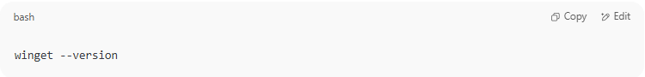
winget --version

If installed, it will show something like:
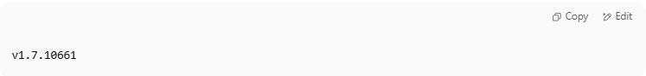
v1.7.10661

🧪 Example: Install cURL with Winget
# Source: AI Source: Provided by: [Data Path: Persons Table -> ID Column: 1, Name_En Column: Motasem Essam] -> From: [Chatgpt (GPT‑5 Mini)] on [1/26/2026]
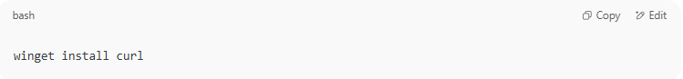
winget install curl

🧠 Winget vs Chocolatey
# Source: AI Source: Provided by: [Data Path: Persons Table -> ID Column: 1, Name_En Column: Motasem Essam] -> From: [Chatgpt (GPT‑5 Mini)] on [1/26/2026]
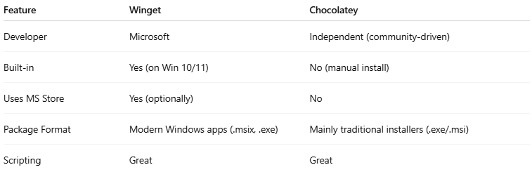

Feature | Winget | Chocolatey
Developer | Microsoft | Independent (community-driven)
Built-in | Yes (on Win 10/11) | No (manual install)
Uses MS Store | Yes (optionally) | No
Package Format | Modern Windows apps (.msix, .exe) | Mainly traditional installers (.exe/.msi)
Scripting | Great | Great

